Module 1: Preventing Pressure Injuries in Hospitals —

Understanding Why Change Is Needed

Module Aim
The aim of Module 1 is to introduce the Preventing Pressure Ulcers in Hospitals Toolkit training.

Module Goals
The goals of this introductory module are to identify the overall objectives of the training, discuss key components of sustainment, describe the Toolkit, and discuss why a hospital would be interested in decreasing pressure injury rates.

Timing
This module will take 45 minutes to present.

Learning Methodology Checklist
- Large group discussion
- PowerPoint slide presentation

Materials Checklist
- LCD projector and laptop
- “Parking lot” flip chart page (with tape or sticky band) and markers

Additional Related Training Resources
- Sustainment — AHRQ Pressure Injury Prevention Program Implementation Sharing Webinar

Instructor Preparation
- Alert the organizational leader (or other appropriate individual) to share what led the organization to begin this pressure injury prevention initiative and how senior leadership plans to support this initiative. Consider developing a project charter to kick off the project. A project charter template can be found at:https://www.ahrq.gov/sites/default/files/wysiwyg/professionals/systems/hospital/qitoolkit/d2-projectcharter.pdf.
- Alert the Implementation Team Leader to be ready to present and discuss the completed Resource Needs Assessment (Tool 1E) in Module 1. Have the Team Leader make copies of the completed needs assessment for each participant, or use the laptop to show the completed needs assessment on the screen.
- Add the specific hospital name to the first slide.
- Make sure to have the PowerPoint file Module 1 cued on the computer and minimized.
- Have a copy of the following for all participants:
- Module 1 PowerPoint slide presentation handout, 3 slides to a page.
- Tool 1E: Resource Needs Assessment (completed by the Implementation Team Leader).
- Sullivan N. Chapter 21. Preventing in-facility pressure ulcers. In: Making Health Care Safer II: An Updated Critical Analysis of the Evidence for Patient Safety Practices. Rockville, MD: Agency for Healthcare Research and Quality; March 2013. https://www.ncbi.nlm.nih.gov/books/NBK133388/. Accessed July 12, 2017.

Module 1: Preventing Pressure Injuries in Hospitals — Understanding Why Change Is Needed
Slide | Script
Slide 1  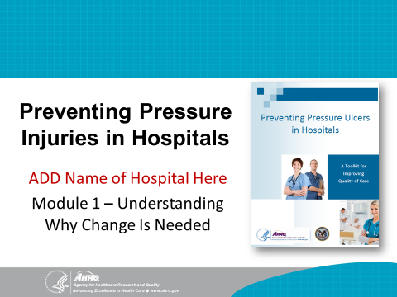 | SAY: Welcome to the training on the Preventing Pressure Ulcers in Hospitals Toolkit. By now, you should all have a copy of the Toolkit in hand. If you don’t, please get one and read through it. There is a wealth of information that will help you plan your Pressure Injury Prevention Program.  My name is (your name), and I will be leading the training today. The purpose of this training is to help you plan a Pressure Injury Prevention Program and to help increase your hospital’s capabilities to develop, implement, and sustain this program.
Slide 2  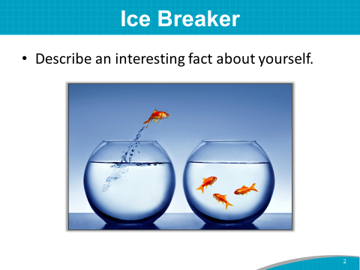 | SAY: I’d like to get to know each of you a little more by doing a fun ice breaker.  Please introduce yourself by stating:  - Your name.  - The department you work in.  - An interesting fact about yourself that others may not know.  Let’s start with the person to my left.  Instructor’s Note: Instead of the ice breaker above, you may ask participants to briefly share a hard lesson they have learned about patients or others with pressure injuries.
Slide 3  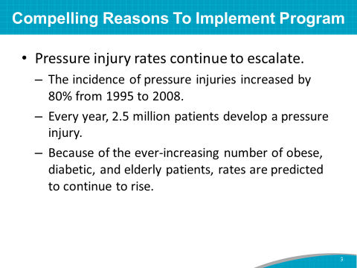 | SAY: There are many compelling reasons for hospital leadership to implement a Pressure Injury Prevention Program.  Pressure injuries are preventable, but pressure injury rates continue to escalate.  Between 1995 and 2008, the incidence of pressure injuries in the United States increased by as much as 80 percent.  Current estimates indicate that 2.5 million patients will develop a pressure injury, and 60,000 U.S. patients will die from complications related to hospital-acquired pressure injuries, or HAPIs.  Because of the ever-increasing number of obese, diabetic, and elderly patients, pressure injury rates are predicted to continue to rise.  Instructor’s Note: Please see references below.  Sullivan N. Chapter 21. Preventing in-facility pressure ulcers. In: Making Health Care Safer II: An Updated Critical Analysis of the Evidence for Patient Safety Practices. Rockville, MD: Agency for Healthcare Research and Quality; March 2013.
Slide 4  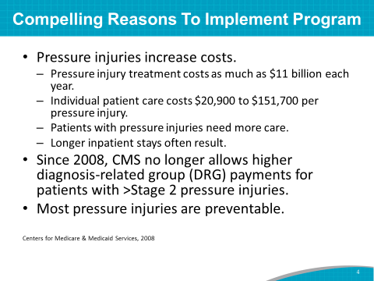 | SAY: There is a business case for pressure injury prevention. Estimates suggest that pressure injury treatment costs could be as high as $11 billion annually.  The estimated cost of individual patient care for Stage 3 and above pressure injuries ranges from $21,000 to more than $151,000 per pressure injury.  The Centers for Medicare and Medicaid Services (CMS) estimated in 2007 that each pressure injury added more than $43,000 in costs to a hospital stay.  Patients with pressure injury morbidity need more care and resources and have longer inpatient stays.  In addition, pressure injuries cause pain and, in some cases, late-stage pressure injuries lead to life-threatening infections.  Often the most compelling case is the business case due to hospital costs. Leadership can often help with resources and removing barriers.  As of 2008, CMS no longer allows higher diagnosis-related group (DRG) payments for patients with Stage 3 and 4 HAPIs.  Lastly and most importantly, most pressure injuries are preventable.
Slide 5  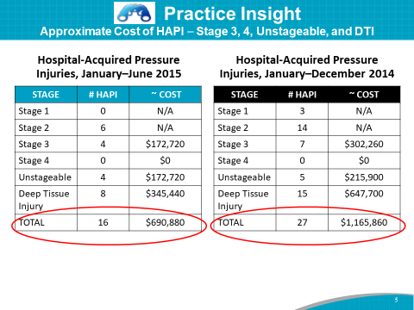 | Practice Insight  SAY: CMS considers a Stage 3 or greater HAPI a “never event” and will not reimburse the hospital for the care required to manage it.  One hospital with several critical care units estimated its costs for care related to HAPIs.  Using the CMS national average cost of $43,000 for a pressure injury “never event,” the team and a member of the hospital’s finance department estimated the nonreimbursed costs the hospital may be incurring for these HAPIs.  The estimated costs grabbed the attention of hospital leadership. Putting the cost along with the HAPI measure makes the cost implications more concrete.  The prevention team wanted to send the message that driving down pressure injury rates means driving down costs.  The Implementation Team Leader stated: “When they see over a million dollars in costs that are not reimbursed—even though it’s estimated—it really gets their attention.” The business case gives leadership an incentive to get on board with the project and support efforts to decrease pressure injury rates.
Slide 6  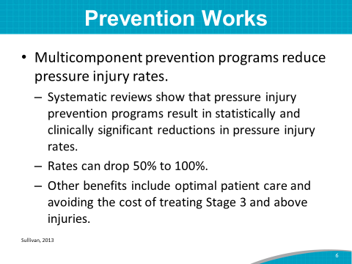 | SAY: A 2011 AHRQ Evidence Report assessed multicomponent in-facility Pressure Injury Prevention Programs.  The review revealed that Pressure Injury Prevention Programs result in statistically and clinically significant reductions in rates and stages of pressure injuries.  The reviews showed a 50 to 100 percent decrease in the rate of pressure injuries in acute care settings after implementation of Pressure Injury Prevention Programs.  Other benefits included optimal patient care and avoiding the cost of treating Stage 3 or 4 injuries.  The Pressure Injury Prevention Program you are implementing is a multicomponent program with best practices similar to those used in these studies.  Instructor’s Note: Please see references below.  Sullivan N. Chapter 21. Preventing in-facility pressure ulcers. In: Making Health Care Safer II: An Updated Critical Analysis of the Evidence for Patient Safety Practices. Rockville, MD: Agency for Healthcare Research and Quality; March 2013.
Slide 7  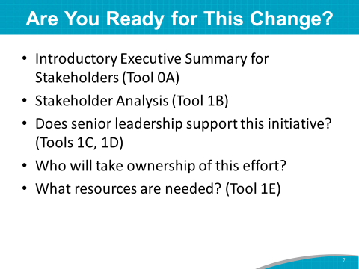 | SAY: Several tools in Section 1 of the Toolkit will help a hospital determine how ready it is to change and to implement a Pressure Injury Prevention Program. Tools 0A, 1B, 1C, 1D, and 1E are designed to assess readiness.  The Team Leaders completed these readiness assessment tools in concert with hospital leadership.  DO: Ask the organizational senior leader (or other appropriate individual) to share what led the organization to conduct this pressure injury prevention initiative, and how senior leadership plans to support this initiative. If there is a project charter, share it with the group now.  SAY: Thank you, (name), for sharing the hospital leadership perspective on this important prevention initiative.  These assessment tools are among the many assessment tools in the Toolkit used to determine opportunities for change.
Slide 8  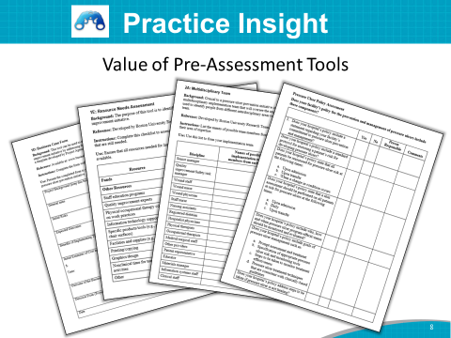 | Practice Insight  SAY: One hospital from the AHRQ pilot study realized the value of using the preassessment tools from the Toolkit. The first thing this hospital’s Implementation Team did as a group was to add monthly meetings with the Chief Nurse Officer, or CNO, because the CNO reports monthly to the C Suite leadership. The Team began sharing the AHRQ prevention project with the CNO and leadership—the project assessments, requirements, and change process.  When they completed the preassessment tools with their facility, they found many opportunities for change. One of the most notable observations was that they provided a great deal of pressure injury and other prevention education for nursing, but almost none for other department staff, such as radiology, transporters, and many other people who touch the patient.  As a result of completing the Toolkit assessment tools, the Prevention Team realized they had many unrecognized needs and shortcomings in their practices. That’s why the AHRQ assessment tools were so valuable for the hospital.  When they realized these limitations, the hospital Implementation Team decided to share the same assessment tools with all the other prevention committees in-house. As a result, the CAUTI, SSI, and Pressure Injury committees used the AHRQ assessment tools, and a speak-up campaign was launched to trend for similar issues.  These items were presented at the Quality Council to the C Suite with a plan to use all the opportunities for improvement.
Slide 9  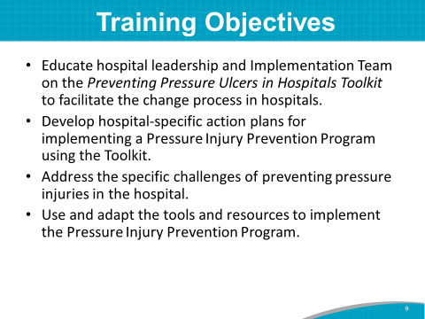 | SAY: Given the need for change in this hospital, the overall objectives for this training are to:  - Educate hospital leadership and the Implementation Team on the Preventing Pressure Ulcers in Hospitals Toolkit to facilitate the process of change in your hospital.  - Develop hospital-specific action plans or revamp your current action plans for your Pressure Injury Prevention Program using the Toolkit.  - Address the specific challenges of pressure injury prevention in your hospital.  - Use and adapt the tools and resources to develop a list of opportunities for improvement, and implement these action plan items in your Pressure Injury Prevention Program.
Slide 10  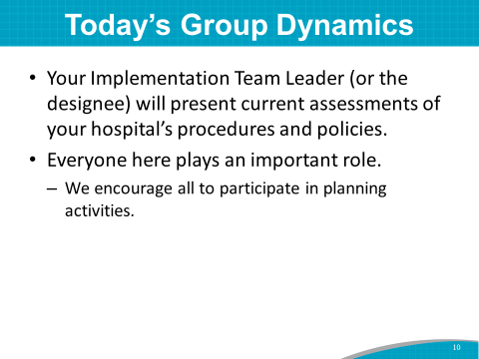 | SAY: Throughout today’s training, (name of the Implementation Team Leader or designee), will present current assessments of your hospital’s pressure injury prevention procedures and policies.  This will help the Team make decisions and plans for implementing best practices for pressure injury prevention.  The Implementation Team has been working hard to complete these assessments, and we appreciate the time they’ve invested.  Let’s give our Team Leader, (name), and (names of others who have done the upfront work) a round of applause.  Everyone in this room is important to the success of the planning and implementation of the Pressure Injury Prevention Program. We need everyone here to participate to the fullest in the planning activities.
Slide 11  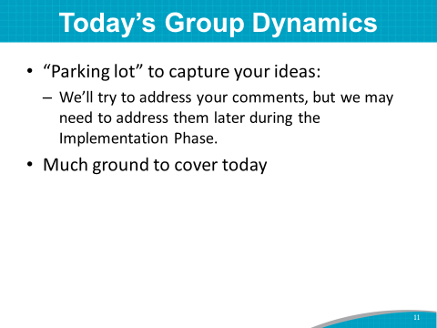 | SAY: We also have a “parking lot” flip chart in the room so we can keep track of your comments and suggestions as we go through the training today. We may not have time to address these comments, but we don’t want to lose them.  We have a lot to cover today. If we are running short of time, we may have to put some items in the “parking lot” to address later.
Slide 12  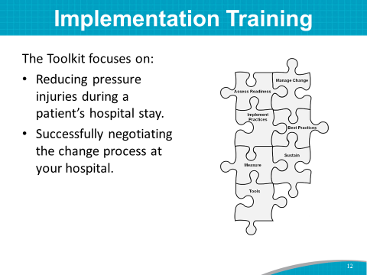 | SAY: The Toolkit focuses on strategies to reduce pressure injuries during a patient’s hospital stay and to negotiate a change process at your hospital.  Systematically working through this change process can help you overcome the challenges associated with updating, implementing, and sustaining a Pressure Injury Prevention Program.
Slide 13  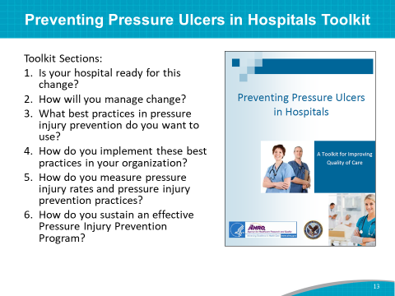 | SAY: The Toolkit is organized under six major questions intended to be used primarily by you, the Implementation Team. The training modules are sequenced according to the Toolkit sections. You are charged with leading the effort to put the new prevention strategies into practice.  As you will see, the Toolkit includes a wealth of information. To train as effectively as possible, we have broken the six sections of the Toolkit into five modules for teaching.  The six sections help you answer these questions:  - Is your hospital ready for this change? (covered in Section 1 and Training Module 1)  - How will you manage change? (covered in Section 2 and Training Module 2)  - What best practices in pressure injury prevention do you want to use? (covered in Section 3 and Training Module 3)  - How do you implement these best practices in your organization? (covered in Section 4 and Training Module 4)  - How do you measure pressure injury rates and pressure injury prevention practices? (covered in Section 5 and Training Module 5)  - How do you sustain an effective Pressure Injury Prevention Program? (covered in Section 6 and all five training modules)  The training follows each section of the Toolkit.
Slide 14  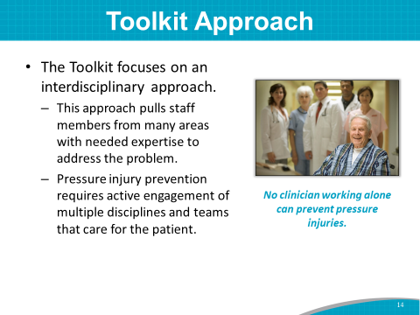 | SAY: The Toolkit is focused on engaging an interdisciplinary Team, including members from many areas with the expertise needed to address the problem.  No hospital professional working alone can prevent all pressure injuries.  Pressure injury prevention requires active engagement of multiple disciplines and teams involved in caring for the patient and his or her family.
Slide 15  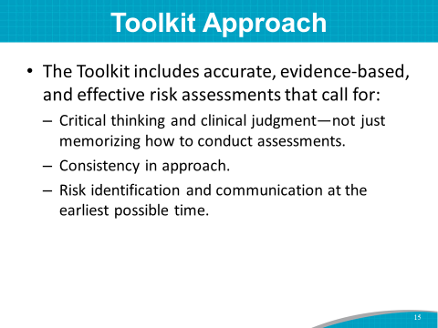 | SAY: The Toolkit includes evidence-based and effective risk assessment tools.  However, tools alone will not improve pressure injury rates. You need to use critical thinking and practical clinical judgment—not just memorize how to conduct assessments.  Consistency in approach is highlighted so all staff in your hospital follow the same approach to preventing pressure injuries.
Slide 16  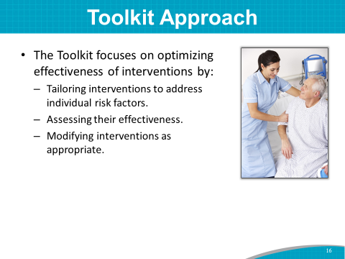 | SAY: The Toolkit will help you optimize the effectiveness and sustainability of interventions.  Tailoring pressure injury interventions to address individual patient risk factors is a best practice.  Assessing the effectiveness of the interventions, and modifying them as appropriate, supports quality improvement practices and is intended to improve pressure injury prevention in the hospital.
Slide 17  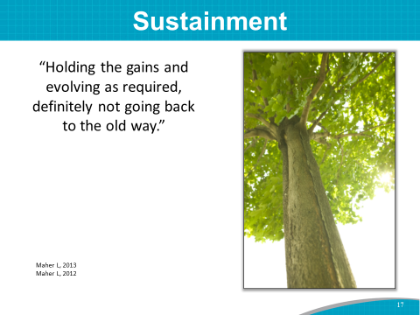 | SAY: Even though sustainment is addressed in Section 6 of the Toolkit, sustainment is so important that we are going to address it right from the beginning and throughout the training modules.  What is sustainment? It is holding the gains we have achieved in pressure injury prevention and evolving as needed with the process changes we have gained, but definitely not going back to the old ways.  This is not a project that ends and we are done. The mindset is that we develop a culture of safety for our patients, and prevention processes are ongoing with the goal of continually working to keep our pressure injury rates low.  Instructor’s Note: Suggest the Team Leaders and potentially the whole Team watch the Sustainment Webinar as an additional related training resource, noted in the front matter.
Slide 18  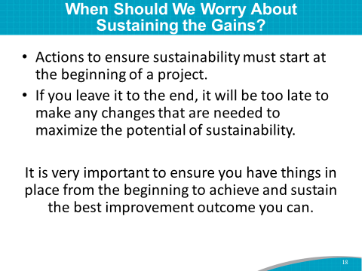 | SAY: A focus on sustainability must begin at the start of a project. People typically think that any consideration or action that might be needed to ensure sustainability of their improvement initiative can wait until the end of the project. We know that if you leave it to the end, it will be too late to make any changes that are needed to maximize the potential of sustainability.
Slide 19  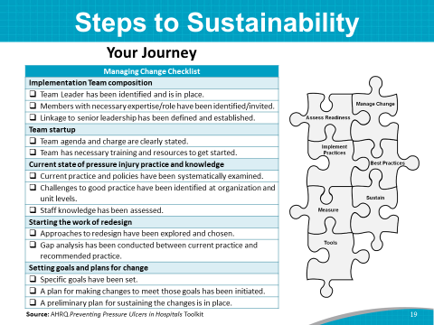 | SAY: This project is an extensive journey of change to make your hospital safer for patients. All the steps in the change process need to be continued and adapted as needed to sustain your gains.  The best practices, collaborations, and tracking measurement are all components that need to be sustained.
Slide 20  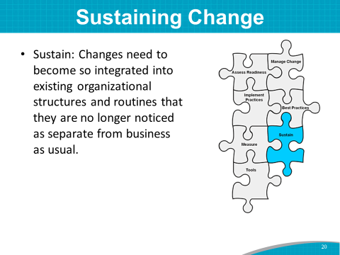 | SAY: The changes should become so integrated into existing organizational routines and structures that they are no longer noticed as separate from business as usual.  The new strategies become the norm. This is how we do it here at our hospital.  This is sustainment.
Slide 21  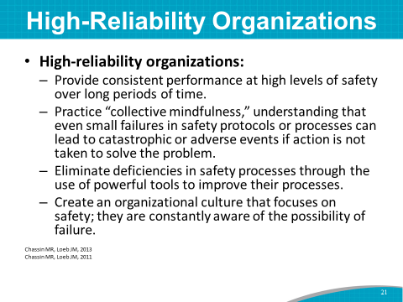 | SAY: We all strive to become high-reliability organizations, where we provide consistent performance at high levels of safety over long periods of time. This is not easy, but it is doable.  Here are the three main components of high-reliability organizations:  - We have “collective mindfulness.” We understand that even small failures in safety protocols can lead to catastrophic or adverse events if action is not taken to solve the problem.  - We eliminate deficiencies in safety processes by using powerful quality improvement tools to improve our processes.  - We create a culture that focuses on safety, and we are constantly aware of the possibility of failure.  Instructor’s Note: Please see references below.  Chassin and Loeb, The Milbank Quarterly, Vol 91 No 3, 2013 pp 459-490; Chassin and Loeb. Health Affairs, April 2011. https://www.ncbi.nlm.nih.gov/pmc/articles/PMC3790522/.
Slide 22  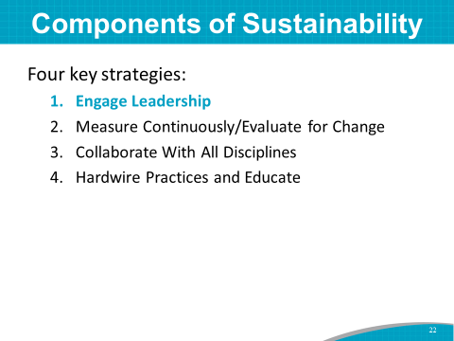 | SAY: Here are four key strategies to sustain your prevention practice successes:  The first is successful engagement of hospital leadership in the safety effort.
Slide 23  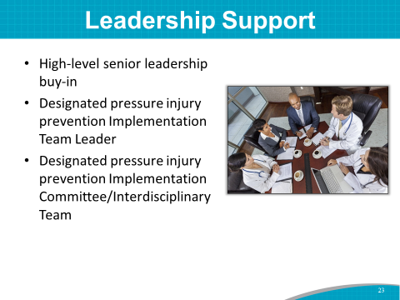 | SAY: All Pressure Injury Prevention Programs need high-level senior administrative leadership support and buy-in. Those with financial decisionmaking capacity should be involved and on the Team.  Lessons learned from key pressure injury prevention initiatives show that support is needed from top-level administration and those at the bedside.  Having a designated Implementation Team and Team Leader (or Co-Leaders) fosters ownership of and commitment to your pressure injury prevention goals and ensures accountability. Having an Administrative Champion involved with the Implementation Team can help get things done.
Slide 24  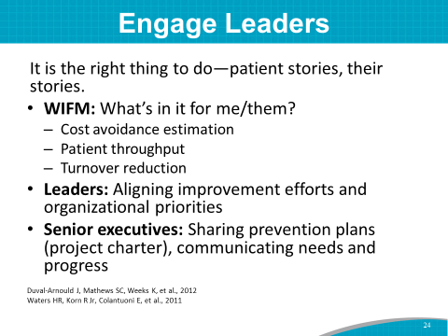 | SAY: Why is leadership engagement important? If leadership does not support what you are doing—and if leadership doesn’t feel the value of safety and hold people accountable—you are not going to get continued long-term change.  How do you get leadership involved? One of the best ways to engage leaders is to tell patient stories of harm and to discuss what drives leadership to act. What is the benefit of safety interventions? Leaders ask, “Why should I worry about this? What’s in it for me?”  Talk to them in their language. For example, in addition to decreasing overall harm to your patients, what is the cost avoidance estimation or the business case for this initiative? Will this initiative save costs over the long run? How will it affect quality scorecards?  How will it help patient throughput (such as the effective and efficient cycling of patients through procedures, imaging, and length of stay)?  An executive sponsor or leader is critical to break down barriers or to increase resources. They help problem solve and get outcomes.  Share your prevention plans, needs, and successes with them.
Slide 25  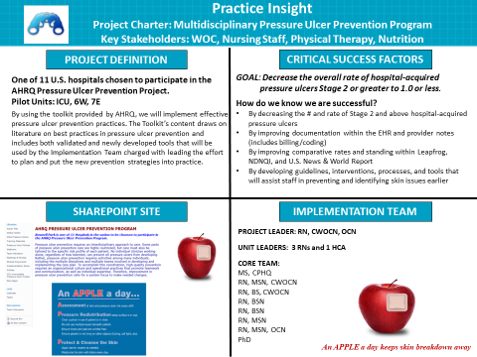 | Practice Insight  SAY: The same hospital that shared their cost-avoidance business case with the hospital board (which was highlighted earlier) continued to share with the board regularly. It shared details about the pressure injury initiative with the board twice in 2 months—once via a board report, and again in a presentation by the CNO at the quarterly board meeting. This sparked interest in a physician member of the board who has expertise in wound care.  In the second meeting, the group presented their project charter at the Quality Committee meeting, which includes five board members, various C-level positions, physicians, vice presidents, and department directors.  The charter included:  - The project and how the hospital used the Toolkit to implement best practices.  - Critical success factors from the Team’s metrics and overall goal (i.e., reduce HAPI Stage 2 and above).  - The detailed Action Plan.  - Core Team members.  - Web portal for collaboration among Team members.  The Team shared metrics for the tools. It also showed how IT issues prevented the Team from completing some of its tasks. With the board’s engagement, many of those tasks can be pushed forward.
Slide 26  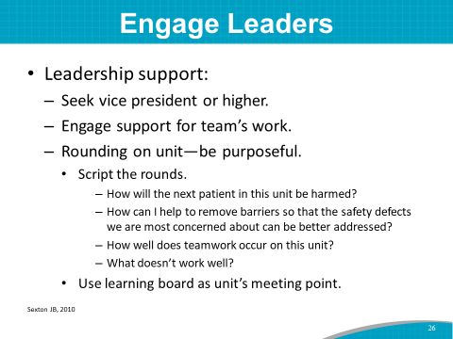 | SAY: In terms of leadership engagement, usually you want to involve a vice president or higher to support the Team’s work. Get someone to pay attention to the good work you are doing.  A key strategy in involving leadership is to invite a senior executive to round on the units with you to show them your facilitators and barriers to success.  Script the rounding that day. Ask the leader to ask frontline staff these suggested questions:  - How will the next patient on this unit potentially be harmed?  - How can I help to remove barriers so that the safety defects can be better addressed?  - How well does teamwork occur on this unit?  - What doesn’t work well?  These are all important issues for a positive safety culture.  If this unit has a learning board, use it as the meeting point. You can look at current pressure injury metrics to see what’s working and what’s not.
Slide 27  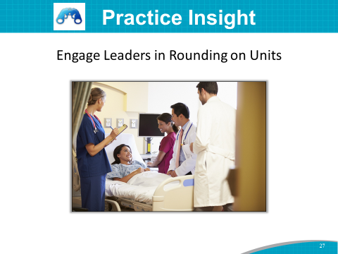 | Practice Insight  SAY: To engage key leadership early in the Pressure Injury Prevention Program, one large hospital’s CEO was invited to make rounds on the unit. To learn more about the program, he showed up and made rounds with the Team.  Three months later, the Executive Team and division leaders were scheduled to round on the units to check on progress and identify any gaps in the program.
Slide 28  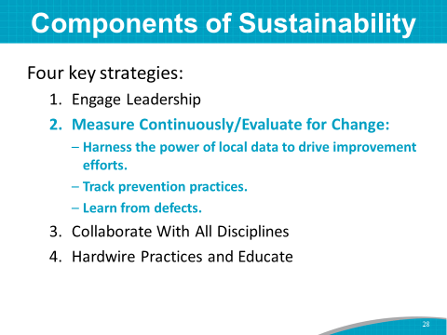 | SAY: The next key strategy for sustainment is to continually measure and track process and outcome measures from the beginning, which is your baseline. These measures tell the story of your prevention efforts.  You absolutely need to collect baseline measures. You need a starting point to track your success, and then you need to continually track pressure injury rates and related outcome measures.  You also need to track prevention practice process measures from the start.  Are staff making the changes you said you were going to in your Action Plan? How do you know?  Track the newly redesigned practices, and check to see if they are being done the right way. For example, are staff individualizing care plans according to risk factors found on risk assessment? How do you know?  If you are still experiencing a higher rate of pressure injuries, learn from defects in your processes.  If you can’t measure it, you can’t improve it.  Set up a measurement committee, and determine a measurement protocol that considers these questions:  - What are you going to measure?  - How often are you going to measure?  - Who will collect the data?  - How will you share the data with frontline staff and leadership?  Instructor’s Note: Toolkit Section 5 and Training Module 5 cover measurement in more detail.
Slide 29  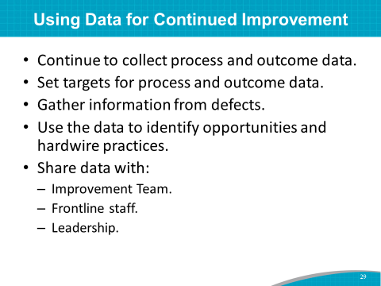 | SAY: Measurement continues indefinitely. Examine your regularly scheduled data collection process for outcome and process measures, to see if you are measuring data that will help your prevention efforts.  Continue to collect process and outcome data during this project and in the Sustainment Phase.  Set targets for outcome and process data.  Gather information from post-pressure injury huddles to see where the process may have broken down. Gather information from your defects, and use this information to identify opportunities for hardwiring practices and to identify next steps.  Share your progress and barriers with frontline staff and leadership.
Slide 30  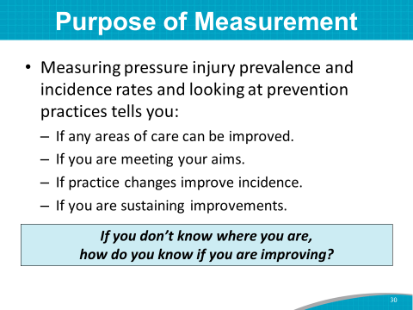 | SAY: Outcome and process data tell a story of how well you are doing and, in many cases, can show where defects may be.  The data tell you:  - What areas of your prevention plan can be improved.  - If you are meeting your aims.  - If your changes to practices are improving pressure injury incidence.  - If you are sustaining improvements.
Slide 31  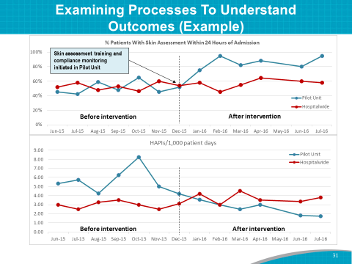 | SAY: This is an example of an annotated run chart that visually tells a story.  Run charts can help you:  - Look for trends and variation.  - See if a process is changing, as in response to a QI initiative.  - See if results are sustained over time.  - Track the implementation of an intervention.  An annotated run chart shows your interventions in relation to the data. This annotated run chart shows pressure injury data over time.  When skin assessment as a prevention practice was instituted on the pilot unit (shown on the blue line), the percentage of patients with a skin assessment within 24 hours increased.  In the same timeframe, HAPIs in the pilot unit decreased markedly.  With no intervention, the overall hospital (shown on the red line) remained about the same on both measures.  DO: Refer to the November 2016 pressure injury Learning Network Webinar on measurement.
Slide 32  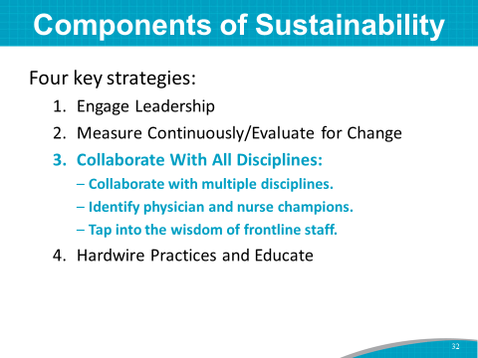 | SAY: The third strategy for sustainment is collaboration with all disciplines. A multidisciplinary group is needed to make changes. Include all disciplines involved with patient care and transfer. Include nurse champions and a physician or two on the Team.  Include frontline staff members on the Team, and provide a forum for them to make suggestions for prevention.
Slide 33  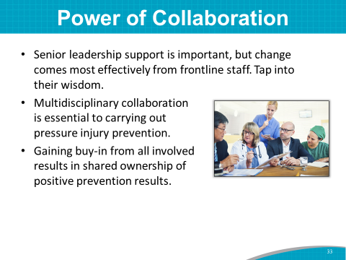 | SAY: Senior leadership support is a prerequisite for system change, but actual change in pressure injury rate and related outcomes of hospitalized patients comes most effectively from the efforts of direct patient care staff.  It is important to get essential input from stakeholders, as well as to secure support and needed resources.  Hospital staff collaboration is essential to carrying out pressure injury prevention with patients.  Getting buy-in from all involved is important and helps to create shared ownership of positive prevention results.
Slide 34  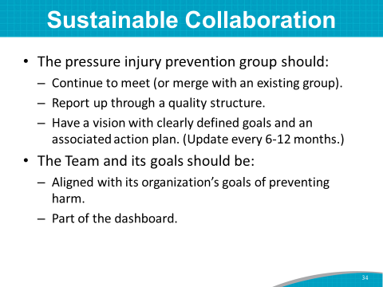 | SAY: What are your plans to keep this prevention effort going long term? After the pressure injury Action Plan prevention work is in place and successful, the Prevention Team will need to:  - Either continue to meet or merge with an existing hospital group.  - Continue to report up through the hospital’s quality structure.  - Continue to have a vision and Action Plan that is reviewed every 6 months or so.  The Team continues to have goals that are aligned with the organization’s culture and goals of preventing harm.  Pressure injury prevention is positioned to be part of the dashboard. Pressure injury prevention continues to be in front of everyone.
Slide 35  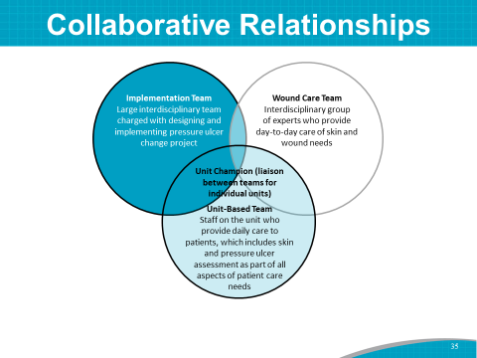 | SAY: This slide shows the overlapping and interdisciplinary nature of the Team roles.  The Prevention Implementation Team, wound care experts, and patient care unit staff need to work together on pressure injury prevention.
Slide: 36  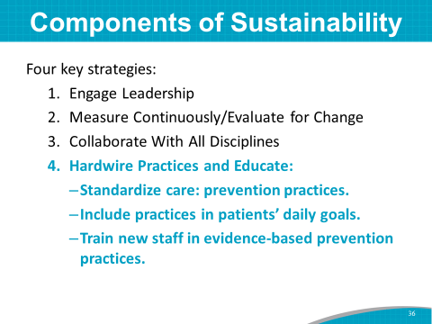 | SAY: Equally important for sustainability is to ensure that prevention strategies to decrease the risk of pressure injuries are hardwired into daily practice. Some of the practices, such as doing a pressure injury risk assessment upon admission, can be hardwired into an EHR.  Use critical thinking to include best practices in patients’ daily goals.  Educating new staff in evidence-based practices ensures that all staff are aware of the culture of safety at this hospital.
Slide 37  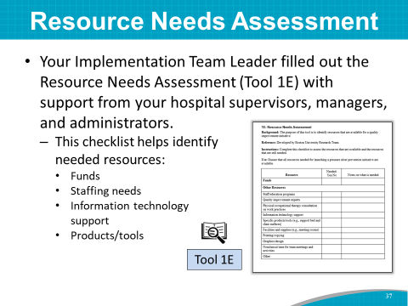 | SAY: Let’s end this module by talking about resource needs.  Tool 1E: Resource Needs Assessment helps to identify resource needs, such as funds, staff education programs, and information technology support.  Your Implementation Team Leader completed this needs assessment tool with support from hospital supervisors, managers, and administrators.
Slide 38  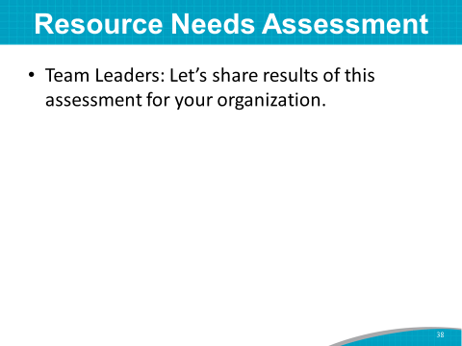 | DO: Ask the Team Leader to share the results of this assessment.  ASK: Does your hospital have any other resource needs in addition to those highlighted in this needs assessment?  SAY: The Administrative Champion on your Team may be able to address these identified resource needs.
Slide 39  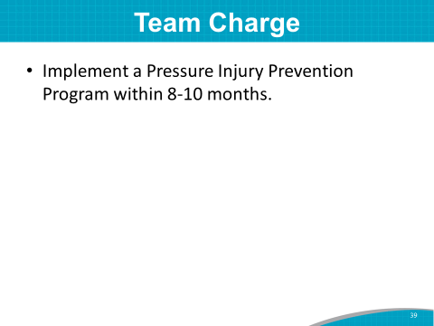 | SAY: Thank you for sharing the results of the Resource Needs Assessment.  The Team charge is to implement a Pressure Injury Prevention Program within 8 to 10 months at this hospital.  ASK: Are there any questions before moving on to Module 2?  SAY: Let’s turn now to Module 2.
Slide 40  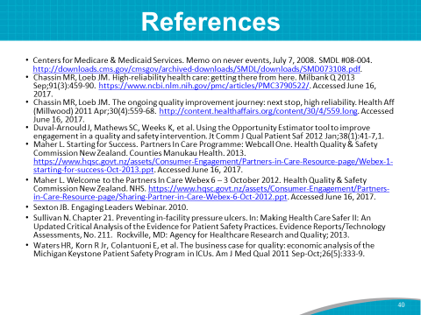 | SAY: References cited in this Module are listed here for those of you who would like to do additional reading.

